Software Requirements Specification

for

GooGrade
Version 3.5.1 approved
Prepared by Paul Phu and Hermyn Mendez
BluGoo
03-06-09
Table of Contents
1. Introduction 1
1.1 Purpose 1
1.2 Project Scope 1
1.3 References 1
2. Overall Description 2
2.1 Product Perspective 2
2.2 Product Features 2
2.3 User Types and Characteristics 2
2.4 Operating Environment 3
2.5 Design and Implementation Constraints 3
2.6 User Documentation 3
2,7 Assumptions and Dependencies 3
3. System Features 4
3.1 View Course 5
3.2 View Announcements 6
3.3 View Grades 7
3.4 View Assignments 8
3.5 Grade Predictor 9
3.6 Manage Courses 11
3.7 Manage Announcements 13
3.8 Manage Grades 14
3.9 Manage Assignments 15
3.10 Manage Accounts 17
3.11 Send Email 19
3.12 Take Attendance 20
3.13 View Roster 21
3.14 Adjust Grading Curve 22
3.15 Edit My Account 23
3.16 Printer Friendly Display 24
3.17 Reset Password 25
4. External Interface Requirements 26
4.1 User Interfaces 26
4.2 Hardware Interfaces 26
4.3 Software Interfaces 26
4.4 Communications Interfaces 26
5. Other Nonfunctional Requirements 27
5.1 Performance Requirements 27
5.2 Safety Requirements 27
5.3 Security Requirements 27
5.4 Software Quality Attributes 27

Revision History
Name | Date | Reason For Changes |  | Version
Paul Phu | 01-29-09 | First Draft |  | 1.0
Hermyn Mendez | 02-02-09 | First Major Revision (edited section 1,2, added 3) |  | 2.0
Hermyn Mendez | 02-05-09 | Added/Revised Section 4 and Appendix C (Kathy, Paul, and Kalvin). Revised sections utilizing the QA document. Synced Section 3 with Use Case List. |  | 2.1
Paul Phu | 2-10-09 | Edits to all sections excluding section 3 |  | 2.2
Paul Phu | 2-11-09 | Add customer input on changes to all sections excluding section 3 |  | 2.3
Paul Phu | 2-11-09 | Revised Appendix and fixed small errors. |  | 2.4
Hermyn Mendez | 2-11-09 | Updated section 3 |  | 2.5
Katherine Blizard | 2-16-09 | Fixed small errors. References, Glossary and Data Dictionary |  | 2.7
Hermyn Mendez | 2-17-09 | Class to Course and Page to Display |  | 2.8
Hermyn Mendez | 2-17-09 |  | Revised Section 3, mostly worked on Functional Requirements and formatting. Pasted in Data Dictionary and tried to bold Data Dictionary terms. | 2.9
Paul Phu | 2-25-09 |  | Revised all Sections excluding section 4. Added revised Data Dictionary and Glossary. Added Survey. | 2.9.1
Hermyn Mendez | 2-25-09 | Updated Section 3 by working on formatting, took out Data Dictionary redundancies, and reworded most the features and functional requirements. Included previously TBD features. |  | 3.0
Paul Phu | 3-3-09 | Fixed minor errors |  | 3.0.1
Hermyn Mendez | 3-6-09 | Fixed some of the comments made on peer review (sections 1, 2, 3). Completely rewrote section 3 to match the new screenshots in Appendix C. |  | 3.5
Paul Phu | 3-7-09 | Fixed minor errors |  | 3.5.1

Introduction

Purpose
This SRS provides specifications for the complete development of GooGrade v1.0. This document states the functionality of GooGrade v1.0. Features for future releases are noted accordingly. All GooGrade v1.0 features have a higher priority than those features noted for follow-up releases. Items in the Data Dictionary will be indicated in bold font for clarity and aid in development. This document is intended for members of the GooGrade development team, the BluGoo team, the customer Lauren Tsung and the user. The SRS contains features and information required for the release of GooGrade v1.0 and possible future releases. It should be read through thoroughly, though the table of contents may be used for immediate references. Sections 1 to 2.2 can give a quick overview of GooGrade while further down this document will give a more detailed specification.

1.2 Project Scope
GooGrade is an open source web based application designed to help teachers track and manage students and their respective grades in a course. It is also designed to allow students to track their grades and compare their progress to the rest of the peers in their course by means of grade metrics. Because GooGrade is open source, it complies with the Open Standard Requirements (OSR) for Software. The OSR states that the GooGrade must be freely available and royalty-free. GooGrade must not have any dependencies on technology that does not comply with the OSR.

For more information regarding the Business Requirements, see section 1 of the GooGrade Vision and Scope.

1.3 References
REF-1:  REF-2:  REF-3:  REF-4:  REF-5:  REF-6:  REF-7:  REF-8:  REF-9: | Open Standard Requirements for Software http://opensource.org/osr  Blugoo Wiki http://wiki.csc.calpoly.edu/blugoo  Schalch, Stephen R. Object Oriented Classical Software Engineering  BluGoo, Vision and Scope Document.  BluGoo, Use Case Document.  Wieger's SRS Example  http://www.csc.calpoly.edu/%7Ecsturner/courses/308w09/srs_template.doc  Web Content Accessibility Guidelines (WCAG) 2.0 http://www.w3.org/TR/WCAG20/  Family Educational Rights and Privacy Act (FERPA). http://www.ed.gov/policy/gen/guid/fpco/ferpa/index.html.  : Nielsen, Jakob. Visualizing Links. http://www.useit.com/alertbox/20040510.html

Overall Description

2.1 Product Perspective
GooGrade’s conception is a response to many already available grading tools which do not effectively package commonly desired student/teacher functionality. Popular grading tools, such as Blackboard, are expensive and do not offer all of the features that GooGrade provides (see Appendix A in Vision and Scope document). GooGrade not only provides a means of editing and tracking grades and progress, it also provides an environment for teachers and students to exchange electronic documents. Most students turn in their assignments to teachers via physical copies. To bring the submission process to the digital world, Cal Poly's Computer Science Department created a UNIX based program called handin to allow students to submit electronic copies of their assignments. Though the process is functional, it can be difficult to use because it requires experience in UNIX. GooGrade offers a web based interface which not only allows students to submit their assignments to teachers, but also allows teachers to upload documents for students to download. For these reasons, we believe GooGrade could replace programs like handin.

Content Diagram - TBD

2.2 Product Features
GooGrade allows Students and Teachers access to a common grading application. Teachers are able to take attendance, add users, manage Assignment Grades, post Announcements and, in release 2, upload Files for Students to download. Students are able to view their grades, view assignment metrics, upload Assignments for submission, and are able to project their final grade with the grade predictor.

2.3 User Types and Characteristics
Teacher | The Teacher is the admin for up to five Courses. They manage Students, their respective grades, Teacher Assistants (see below), Assignments, and they also have the ability to post Announcements and upload documents for the Students.
Teacher Assistant | The Teacher Assistant is a lower admin. They are managed and given permissions by the Teacher. If the Teacher desires, the Teacher Assistant may have all of the functionality that a Teacher has.
Student | The Students are able to view their grades and any Announcements posted by the Teacher and Teacher Assistant for a given Course. They are also given access to Assignment Metrics and also have the ability to upload Assignments for submission.

2.4 Operating Environment
OE-1:  OE-2:  OE-3: | GooGrade will support the following web browsers: Firefox 3, Safari 3, and Internet Explorer 7.  GooGrade has the ability to run on Linux servers.  Access to GooGrade is available anywhere there is internet access.

2.5 Design and Implementation Constraints
CO-1:  CO-2:  CO-3:  CO-4:  CO-5 | GooGrade will be web based.  All HTML shall meet the W3C XHTML 1.1 Standard.*  All CSS shall meet the W3C CSS level 2.1 Standard* to support a similar look.  GooGrade must have the same functionality across all supported web browsers (see OE-1).**  GooGrade will not display any information to an unauthorized User.***

*As recommended by the Customer
**As recommended by W3C
***As enforced by law by FERPA

2.6 User Documentation
Instructions on how to use GooGrade shall be provided online on our website (see section 1.3) and included with GooGrade.

2.7 Assumptions and Dependencies
Assumptions:
AS-1 The storage space of user information and grades will be accessible to users at all times regardless of high volume loads trying to access the grading application simultaneously.
AS-2 Course prerequisites are met by enrolled Student(s).
AS-3 All Student(s) are enrolled in the Course.
AS-4 All changes made to the storage space of user information and grades of the grading application take effect immediately.
Dependencies:
DE-1 The system will need to be hosted at an address on the Internet with encryption.
DE-2 The system depends on the Teacher and Teacher Assistant keeping Course rosters and any Assignment accurate and up to date.

3. System Features
User (Role) | Section | Feature Name | Brief Description
Student | 3.1 | View Course | Allows the Student to view the Course information.
Student | 3.2 | View Announcements | Allows the Student to view the Course Announcements.
Student | 3.3 | View Grades | Allows the Student to view their grades.
Student | 3.4 | View Assignments | Allows the Student to access Files and descriptions for each Assignment.
Student | 3.5 | Grade Predictor | Calculates, for the student, what Assignment Scores they need to earn a desired grade.
Teacher and Teacher Assistant | 3.6 | Manage Courses | Allows the admin to add, edit, and remove Courses.
Teacher and Teacher Assistant | 3.7 | Manage Announcements | Allows the admin to add, edit, and remove Announcements.
Teacher and Teacher Assistant | 3.8 | Manage Grades | Allows the admin to add, edit, and remove Student Assignment Scores.
Teacher and Teacher Assistant | 3.9 | Manage Assignments | Allows the admin to add, edit, and remove Assignments.
Teacher and Teacher Assistant | 3.10 | Manage Accounts | Allows the admin to add, edit, and remove Accounts
Teacher and Teacher Assistant | 3.11 | Send Emai | Allows the admin to send emails to either individuals or the entire Course.
Teacher and Teacher Assistant | 3.12 | Take Attendance | Allows the admin to take attendance for the Course.
Teacher and Teacher Assistant | 3.13 | View Roster | Displays, for the admin, a list of everyone enrolled in the Course.
Teacher and Teacher Assistant | 3.14 | Adjust Grading Curve | Allows the admin to adjust the grading curve for the Course.
All | 3.15 | Edit My Account | Allows all users to edit their Email Address and Password. Only the Teacher may adjust their Username.
All | 3.16 | Printer Friendly Display | Displays a “printer friendly” version of the current display.
All | 3.17 | Reset Password | Randomly generates a new Password and sends it to the user Email Address.

3.1 View Course
3.1.1 Description and Priority
Description | The system displays the Course data items. These include all data items in the Course (see Appendix B: Data Dictionary).
Priority | Low

3.1.2 Stimulus/Response Sequences
Stimulus | User selects “View Course”
Response | System takes user to the “View Course” display. (see Appendix C for examples of displays)

3.1.3 Functional Requirements
REQ-1.1: When user selects “View Course,” the system displays the Course data items. These include all data items in the Course (see Appendix B: Data Dictionary).

3.2 View Announcements
3.2.1 Description and Priority
Description | The system displays a list of the 20 most recent Announcement(s) posted by the Teacher sorted with the most recently posted Announcement at the top of the list. All Announcements are collapsed into a single header except the Announcement at the top of the page being viewed. (See Appendix C, C-2)
Priority | High

3.2.2 Stimulus/Response Sequences
Stimulus | User selects “View Announcements”
Response | System takes user to the “View Announcements” display
Stimulus | User selects a collapsed Announcement.
Response | System expands Announcement such that the Announcement Text is visible under the Announcement Date and Announcement Title.
Stimulus | User selects a page number.
Response | System displays the announcements contained on that page number.
Stimulus | User selects PREV or NEXT
Response | System takes the user to either the previous or next page, respectively.

3.2.3 Functional Requirements
REQ-2.1: When user selects “View Announcements,” system displays a list of the 20 most recent Announcement(s) posted by the Teacher sorted with the most recently posted Announcement at the top of the list.
REQ-2.2: If no Announcement has been made the system displays a "No Announcements Exist.”
REQ-2.3: By default, when a page is being viewed, only the Announcement at the top of the list is expanded. The rest are collapsed.
REQ-2.4: If the user is currently viewing “page 1” of the Announcements, the “PREV” link is disabled.
REQ-2.5: If the user is currently viewing the last page of the Announcements, the “NEXT” link is disabled.
REQ-2.6: If there are more than 20 Announcements, the system creates more pages to accommodate the additional Announcements. By accommodate, subsequent pages are created such that each page only contains, at most, 20 Announcements. “Page 1” will contain the 20 most recent Announcements and subsequent pages will contain the, up to, 20 preceding Announcements until the last page contains the, up to, 20 oldest Announcements.
REQ-2.7: The system displays only 5 page links at one time. Initially only the first 5 are displayed. If the user moves to page 5, the system will display page links 2-6. Beyond that, if the user moves to page “n,” the system will display page links “n-3” to “n+1”. If page “n” is the last page, then page links “n-4” to “n” are displayed instead.

3.3 View Grades
3.3.1 Description and Priority
Description | The system displays a table containing the Student’s Assignment Grades in chronological order with the Total Grade at the bottom of the table. It will also contain the Assignment Metrics for any Assignment displayed. Above this table is a Course grade distribution bar graph and the Student’s current grade in the Course. Current grade is based only on Assignments with Assignment Scores.(see Appendix C, C-4)
Priority | High

3.3.2 Stimulus/Response Sequences
Stimulus | User selects “View Grade”
Response | System takes user to the “View Grade” display. (see Appendix C, C-4 for example)
Stimulus | User selects a column on the table displayed
Response | System sorts the table with respect to the column selected.

    - Functional Requirements
REQ-3.1: When user selects “View Grade,” the system displays a table containing the Student’s Assignment Grades in chronological order with the Total Grade at the bottom of the table. It will also contain the Assignment Metrics for any Assignment displayed. Above this table is a Course grade distribution bar graph and the Student’s current grade in the Course. Current meaning grade based only on Assignments with Assignment Scores (see Appendix C, C-4)
REQ-3.2: If the user selects a column header, the system sorts the table with respect to that column. If the column contains numbers, it will be sorted in ascending numerical order (highest on top). Otherwise, it will be sorted in descending alphabetical order (A/a on top).
REQ-3.3: Total Grade will always be kept at the bottom of the table (design choice by BluGoo).
REQ-3.4: If an Assignment has no Assignment Score, the system displays the Assignment name with the Assignment Score field blank.
REQ-3.5: If an Assignment has no Assignment Metrics, the system displays the Assignment Metrics fields blank.
REQ-3.6: If no Assignments exist yet, the system displays the words “No Assignments Exist.”
REQ-3.7: The “bar” in the bar graph in which the Student’s current grade or Assignment grade (see REQ 3-8) lies in will be colored (highlighted) differently than the rest (see Appendix C, C-4 for example).
REQ-3.8: If the user selects an Assignment Name from the table, the Course distribution graph will change to a distribution graph for the Assignment, and the display will move to the top to put the graph in view. It will display a distribution of letter grades for the Assignment and the caption below the graph will change to “[Assignment Name] Grade Distribution.”

3.4 View Assignments
3.4.1 Description and Priority
Description | The system displays a table containing the Course’s Assignments in chronological order with the most recently posted Assignment at the bottom of the table. The Assignment Name of the Assignment is a link to the Assignment Description. All other Assignment data items and links to upload and download Files are shown in the table. (see Appendix C, C-3)
Priority | Medium Low

3.4.2 Stimulus/Response Sequences
Stimulus | User selects “View Assignments”
Response | System takes user to the “View Assignments” display.
Stimulus | User selects an Assignment Name.
Response | System displays the Assignment Description.
Stimulus | User selects “Download.”
Response | System prompts the user for a location to save the Files for the Assignment.
Stimulus | User selects “Upload.”
Response | System prompts the user for a location of the File being submitted for that Assignment.

    - Functional Requirements
REQ-4.1: When user selects “View Assignments,” the system displays a table containing the Course’s Assignments in chronological order with the most recently posted Assignment at the bottom of the table. (See Appendix C, C-3)
REQ-4.2: When user selects an Assignment Name, the system opens a new display (new pop-up window) which contains the Assignment Description.
REQ-4.3: When user selects “Download,” the system prompts the user for a location to save the Files for the Assignment.
REQ-4.4: When user selects “Upload,” the system prompts the user for the location of the File to be submitted for that Assignment.
REQ-4.5: If there are Files for the Assignment, a “Download” link will be displayed for that Assignment.
REQ-4.6: The system displays the total of the Assignment Totals at the bottom of the table.
Others: REQ-3.6

Grade Predictor
3.5.1 Description and Priority
Description | The system displays the grades possible called “desired grades” (excluding “F”), the Students current grade, and two tables; one containing Assignments with Assignment Scores and one containing Assignments with no Assignment Scores. (see Appendix C, C-5)
Priority | Medium Low

3.5.2 Stimulus/Response Sequences
Stimulus | User selects “Grade Predictor”
Response | System takes user to the “Grade Predictor” display. This display contains a selection of desired grades
Stimulus | User selects a desired grade (see Appendix C, C-5 for example).
Response | System displays the needed Assignment Scores for Assignments, without Assignment Scores, to get a desired final grade.

3.5.3 Functional Requirements
REQ-5.1: When user selects “Grade Predictor,” the system displays the grades possible called “desired grades” (excluding “F”), the Student’s current grade, and two tables; one which contains Assignments with Assignment Scores and one which contains Assignments with no Assignment Scores. (see Appendix C, C-5)
REQ-5.2: When user selects a desired grade, the system runs the algorithm described in section 3.3.4 to obtain a one possible set of Assignment Scores that would earn the Student the desired grade.
REQ-5.3: If there are no more Assignments without Assignment Scores, the system displays the student’s final grade and “No More Ungraded Assignments.”
REQ-5.4: If no Assignments have Assignment Scores, system displays “No Graded Assignments Exist.”
REQ-5.5: If the desired grade is no longer possible based upon the algorithm describe in section 3.5.4, the system displays “Grade Not Possible.”
Others: REQ-3.6
3.5.4 Grade Predictor Algorithm (for example in Appendix C, C-5)

lowerBoundC = 0.7; // 70% is the lowest “C”
totalPointsPossible = 320;
totalPointsToDate = 169;

lowestC = lowerBoundC * totalPointsPossible; //224
pointsNeeded = lowest – totalPointsToDate; //55
quiz2PredictedScore = quiz2TotalPointsPossible; //10
midterm2PredictedScore = midterm2TotalPointsPossible; //100

while(pointsNeeded > 0)
{
if(quiz2PredictedScore > 0)
quiz2PredictedScore -= 1;
if(pointsNeeded == 0)
Break;
if(midterm2PredictedScore > 0)
midterm2PredictedScore -= 1;
if(pointsNeeded == 0)
Break;
if(quiz2PredictedScore == 0 && midterm2PredictedScore == 0 )
return “Grade Not Possible”;
}

return quiz2PredictedScore, midterm2PredictedScore; //0, 55

3.6 Manage Courses
3.6.1 Description and Priority
Description | The system displays a selection of icons, at all times, which allow the user to add, edit, remove, import and export Courses. (see Appendix C, C-8)
Priority | Low

3.6.2 Stimulus/Response Sequences
Stimulus | User is logged in the system.
Response | System displays a selection of icons to add, edit, remove, import and export Courses.
Stimulus | User selects to edit a Course.
Response | System displays the Course and the data items it editable fields.
Stimulus | User edits the Course and selects “Accept”
Response | System returns to the display from which the edit Course was selected.
Stimulus | User selects to remove a Course.
Response | System prompts the user to confirm removal (see C-10 sample prompt)
Stimulus | User selects “Remove”
Response | System returns to the display from which the remove Course was selected.
Stimulus | User selects to add a Course.
Response | System displays Course data items it editable fields.
Stimulus | User enters the Course data items and selects “Accept”
Response | System returns to the display from which the add Course was selected.
Stimulus | User selects to import a Course.
Response | System prompts user for a file containing a Course.
Stimulus | User selects the location of the File and selects “Accept”
Response | System returns to the display from which the import Course was selected.
Stimulus | User selects to export a Course.
Response | System prompts user to enter a location to save the File.
Stimulus | User select a location for File and selects “Accept”
Response | System returns to the display from which the export Course was selected.

3.6.3 Functional Requirements
REQ-6.1: The system displays a selection of icons, at all times, which allow the user to add, edit, remove, import and export Courses. (see Appendix C, C-8)
REQ-6.2: When user selects to edit a Course, the system displays the data items in editable data fields. If the user selects “Accept,” the system will save the Course and system returns to the display from which the edit Course was selected.
REQ-6.3: When user selects to remove a Course, the system prompts the user to confirm the removal (see Appendix C, C-10). If the user selects “Remove,” the system returns to the display from which the remove Course was selected.
REQ-6.4: When user selects to add a Course, the system displays the data items in editable data fields. If the user selects “Accept,” the system will save the Course and system returns to the display from which the add Course was selected.
REQ-6.5: When user selects to import a Course, the system prompts the user for a File containing a Course. Once the user has entered the File, the system will save the Course and system returns to the display from which the add Course was selected.
REQ-6.6: When user selects to export a Course, the system prompts the user for a location to save a File containing the Course. Once the user has entered the location, the system returns to the display from which the add Course was selected.
REQ-6.7: If user selects “Accept” while adding, importing, or editing a Course and all of the Course has not been entered, the system displays “The Following information is Missing: “and lists the fields that are empty.
REQ-6.8: If user selects “Accept” while adding, importing, or editing a Course and the Course Title, Course Section, or Course Number already exist, the system displays “Course Already Exists: ” and displays the existing Course.

3.7 Manage Announcements
3.7.1 Description and Priority
Description | The system shall display “View Announcements” (see section 3.2) with added management features.
Priority | High

3.7.2 Stimulus/Response Sequences
Stimulus | User selects “Manage Announcements”
Response | System takes user to the “View Announcements” display with added features (see description)

Stimulus | User selects to edit an Announcement.
Response | System displays the Announcement and the data items it editable fields.
Stimulus | User edits the Announcement and selects “Accept”
Response | System saves the Announcement and returns to “Manage Announcements.”

Stimulus | User selects to remove an Announcement.
Response | System prompts the user to confirm removal (see Appendix C, C-10)
Stimulus | User selects “Remove”
Response | System removes the Announcement and returns to “Manage Announcements.”

Stimulus | User selects to add an Announcement.
Response | System displays Announcement data items it editable fields.
Stimulus | User enters the Announcement data items and selects “Accept”
Response | System saves the Announcement and returns to “Manage Announcements.”

3.7.3 Functional Requirements

REQ-7.1: When user selects “Manage Announcements,” system shall display “View Announcements” (see section 3.2) with added management features. These features shall include add, edit, and remove Announcements. (see Appendix C, C-9)

REQ-7.2: When user selects to edit an Announcement, the system shall display the data items in editable data fields. If the user selects “Accept,” the system shall save the Announcement and return to the “Manage Announcements” display.

REQ-7.3: When user selects to remove an Announcement, the system shall prompt the user to confirm the removal (see Appendix C, C-10). If the user selects “Remove,” the system shall remove the Announcement and return to the “Manage Announcements” display.

REQ-7.4: When user selects to add an Announcement, the system shall display the data items in editable data fields. If the user selects “Accept,” the system shall save the Announcement and return to the “Manage Announcements” display.

REQ-7.5: If user selects “Accept” while adding, importing, or editing an Announcement and all of the Announcement has not been entered, the system shall display “The Following information is Missing: “ and list the fields that are empty.

Others: REQ-2.2, REQ-2.3, REQ-2.4, REQ-2.5, REQ-2.6

3.8 Manage Grades
3.8.1 Description and Priority
Description | The system shall display a table of editable fields corresponding to Students’ Assignment Scores.
Priority | High

3.8.2 Stimulus/Response Sequences
Stimulus | User selects “Manage Grades”
Response | System displays the “Manage Grades” display.
Stimulus | User enters Assignment Scores into the table and selects “Save.”
Response | System saves the Assignment Scores and returns to “Manage Grades”

3.8.3 Functional Requirements

REQ-8.1: The system shall display a table of fields (a grid) with the Course’s Students on the right and the Course’s Assignments on the top. The fields shall be editable, though the user must select “Save” to save the changes. Above the table shall be the Course grade distribution graph (identical to the graph in “View Grades”) (see Appendix C, C-13).

REQ-8.2: If no Assignments exist, the system shall display “No Assignments Exist” and a link to add Assignment.

REQ-8.3: If no Students exist, the system shall display “No Students Exist” and a link to add Student.

3.9 Manage Assignments
3.9.1 Description and Priority
Description | The system shall display “View Assignments” (see section 3.4) with added management features.
Priority | High

3.9.2 Stimulus/Response Sequences
Stimulus | User selects “Manage Assignments”
Response | System takes user to the “View Assignments” display with added features (see description)

Stimulus | User selects to edit an Assignment.
Response | System displays the Assignment and the data items it editable fields.
Stimulus | User edits the Assignment and selects “Accept”
Response | System saves the Assignment and returns to “Manage Assignments.”

Stimulus | User selects to remove an Assignment.
Response | System prompts the user to confirm removal (see Appendix C, C-10)
Stimulus | User selects “Remove”
Response | System removes the Assignment and returns to “Manage Assignments.”

Stimulus | User selects to add an Assignment.
Response | System displays Assignment data items it editable fields.
Stimulus | User enters the Assignment data items and selects “Accept”
Response | System saves the Assignment and returns to “Manage Assignments.”

Stimulus | User selects to import an Assignment.
Response | System prompts the user for the location of a File that contains an Assignment
Stimulus | User enters the location of the file.
Response | System saves the Assignment and returns to “Manage Assignments.”

Stimulus | User selects to “Upload”
Response | System prompts the user for the location of a File for the Assignment

Stimulus | User selects to “Download Assignment Files”
Response | System prompts the user for the location to save the Assignment Files.

Stimulus | User selects to “Download Student Files”
Response | System prompts the user for the location to save the Files submitted by Students for the Assignments.

3.9.3 Functional Requirements

REQ-9.1: When user selects “Manage Assignments,” system shall display “View Assignments” (see section 3.2) with added management features. These features include add, import, edit, and remove Assignments. (see Appendix C, C-11)

REQ-9.2: When user selects to edit an Assignment, the system shall display the data items in editable data fields (see Appendix, C-12). If the user selects “Accept,” the system shall save the Assignment and return to the “Manage Assignments” display.

REQ-9.3: When user selects to remove an Assignment, the system shall prompt the user to confirm the removal. If the user selects “Remove,” the system shall remove the Assignment and return to the “Manage Assignments” display.

REQ-9.4: When user selects to add an Assignment, the system shall display the data items in editable data fields. If the user selects “Accept,” the system shall save the Assignment and return to the “Manage Assignments” display.

REQ-9.5: When user selects to import an Assignment, the system shall prompt the user to select a File. When the user selects a File containing an Assignment, the system shall save the Assignment and return to the “Manage Assignments” display.

REQ-9.6: When user selects to “Upload,” the system shall prompt the user for the location of a File for the Assignment. When the user enters the location, the File shall be saved and the system shall return to “Manage Assignments.”

REQ-9.7: When user selects to “Download Assignment Files,” the system shall prompt the user for the location to save the Files for the Assignment.

REQ-9.8: When user selects to “Download Student Files,” the system shall prompt the user for the location to save the Files by the Students for the Assignment.

REQ-9.9: If user selects “Accept” while adding, importing, or editing an Assignment and all of the Assignment has not been entered, the system shall display “The Following information is Missing: “and list the fields that are empty.

REQ-9.10: If user selects “Accept” while adding, importing, or editing a Assignment and the Assignment Title, Assignment Section, or Assignment Number already exist, the system shall display “Assignment Already Exists: ” and displays the existing Assignment.

REQ-9.11: The “Download Assignment Files” shall be displayed when there are Files for that Assignment.

REQ-9.12: The “Download Student Files” shall be displayed when there are Files submitted by the Students for that Assignment.

Others: REQ3.6, REQ-4.2, REQ-4.6

3.10 Manage Accounts
3.10.1 Description and Priority
Description | The system shall display table of Students and Teacher Assistants in the Course, and their data items (including what Courses they are in). The user may add, import, edit, and remove Accounts. (see Appendix C, C-14)
Priority | High

3.10.2 Stimulus/Response Sequences
Stimulus | User selects “Manage Accounts”
Response | System takes user to the “Manage Accounts” display (see Appendix C, C-14)

Stimulus | User selects to edit an Account.
Response | System displays the Account and the data items it editable fields. (see Appendix C, C-15)
Stimulus | User edits the Account and selects “Accept”
Response | System saves the Account and returns to “Manage Accounts.”

Stimulus | User selects to remove an Account.
Response | System prompts the user to confirm removal
Stimulus | User selects “Remove”
Response | System removes the Account and returns to “Manage Accounts.”

Stimulus | User selects to add an Account.
Response | System displays Account data items it editable fields.
Stimulus | User enters the Account data items and selects “Accept”
Response | System saves the Account and returns to “Manage Accounts.”

Stimulus | User selects to import an Account.
Response | System prompts the user for the location of a File that contains an Account
Stimulus | User enters the location of the file.
Response | System saves the Account and returns to “Manage Accounts.”

3.10.3 Functional Requirements

REQ-10.1: When user selects “Manage Accounts,” system shall display table of Students and Teacher Assistants in the Course, and their data items (including what Courses they are in). The user may add, import, edit, and remove Accounts. (see Appendix C, C-14)

REQ-10.2: When user selects to edit an Account, the system shall display the data items in editable data fields (see Appendix, C-15). It also contains a list of Courses to which the Account may be added to by checking the box next to the Course Name. If the Account is a Teacher Aid, the system shall display a list of Permissions which may be edited by checking or un-checking the respective boxes (see Appendix C, C-15).

REQ-10.3: When user selects to remove an Account, the system shall prompt the user to confirm the removal. If the user selects “Remove,” the system shall remove the Account and return to the “Manage Accounts” display.

REQ-10.4: When user selects to add an Account, the system shall display the data items in editable data fields. If the user selects “Accept,” the system shall save the Account and return to the “Manage Accounts” display.

REQ-10.5: When user selects to import an Account, the system shall display prompts the user to select a File. When the user selects a File containing an Account, the system shall save the Account and return to the “Manage Accounts” display.

REQ-10.6: If user selects “Accept” while adding, importing, or editing an Account and all of the Account has not been entered, the system shall display “The Following information is Missing: “and list the fields that are empty.

REQ-10.7: If user selects “Accept” while adding, importing, or editing an Account Name, Username, or Email Address already exist, the system shall display “Account Already Exists: ” and the existing Account.

REQ-10.8: If the user attempts to add a Teacher Assistant to a Course which already has one, the system shall display “A Teacher Assistant already exists in: “ and the Course Name.

REQ-10.9: If the user attempts to add a Teacher Assistant or Student without assigning then to, at least, one Course, the system shall display “The account must be enrolled in, at least, one course.”

REQ-10.10: If no Accounts exist, the system shall display “No Accounts Exist” and provides a link to add an Account.

3.11 Send Email
3.11.1 Description and Priority
Description | The system prompts the user for information required for an Email to be sent. Once the user enters the information and selects “Send,” then system sends the Email.
Priority | Medium Low

3.11.2 Stimulus/Response Sequences
Stimulus | User selects “Send Email”
Response | System takes user to the “Send Email” display. This prompts the User to information about the Email being sent.
Stimulus | User inputs information
Response | System displays confirmation.

    - Functional Requirements
REQ-11.1: When user selects “Send Email,” the system displays blank fields which represent a new Email.
REQ-11.2: When user selects “Send” and all the information has been entered, the system sends the Email.
REQ-11.3: When user selects “Send” and all of the information has not been entered, the system displays “The Following Information is Missing: “and lists the fields that are empty.
REQ-11.4: If the user selects “Send” with an invalid Username, Course Name or EmailAddress, the system displays “Invalid Recipient(s).”
REQ-11.5: If user selects “Send” while all of the Email has not been entered, the system displays “The Following information is Missing: “and lists the fields that are empty.

3.12 Take Attendance
3.12.1 Description and Priority
Description | The system displays a table of Students and the current week’s calendar dates (a grid). The table is a grid of check-boxes and the user may mark Students present by checking the check-boxes. (See Appendix C, C-16)
Priority | Medium Low

3.12.2 Stimulus/Response Sequences
Stimulus | User selects “Take Attendance”
Response | System takes user to the “Take Attendance” display. The system displays a table of Students and the current week’s calendar dates.
Stimulus | User edits the attendance records by checking or un-checking the boxes and selects “Accept.”
Response | System saves the attendance records.
Stimulus | User selects to move forward, or backward a calendar week.
Response | System displays the table with the next, or previous week’s dates.

    - Functional Requirements
REQ-12.1: When user selects “Take Attendance,” The system displays a table of Students and the current week’s calendar dates (a grid). The table is a grid of check-boxes and the user may mark Students present by checking the check-boxes. (See Appendix C, C-16)
REQ-12.2: When user selects “Next,” the system changes the calendar week, which is being displayed in the table, to 1 week ahead of what is currently being displayed. The week’s displayed “starting date” is also changed.
REQ-12.2: When user selects “Prev,” the system changes the calendar week, which is being displayed in the table, to 1 week before what is currently being displayed. The week’s displayed “starting date” is also changed.
REQ-12.3: When user selects “Accept,” the system stores the changes.
REQ-12.4: If no Students exist, the system displays “No Students Exist.”

3.13 View Roster
3.13.1 Description and Priority
Description | The system a list of Students who are in the Course. This list includes the Student’s Name, Username, Email, and Courses. It will not display their Password.
Priority | Medium High

3.13.2 Stimulus/Response Sequences
Stimulus | User selects “View Roster”
Response | System displays a Course roster.

    - Functional Requirements
REQ-13.1: When user selects “View Roster,” the system displays a list of Students in the Course. This list includes the Student’s Name, Username, Email, and Courses. It will not display their Password.
REQ-13.2: If no Students exist, the system displays “No Students Exist.”

3.14 Adjust Grading Curve
3.14.1 Description and Priority
Description | The system displays two pie graphs, side by side, and below those is a box to adjust the grading curve. One graph is a pie chart split into sections which represent letter grade percentage ranges (i.e. 90% to 100% is an A for many Courses). The other is a Course grade distribution graph, each section representing a letter grade and showing how many students have that grade based upon the current grading curve. (see Appendix C, C-17).
Priority | Medium

3.14.2 Stimulus/Response Sequences
Stimulus | User selects “Adjust Grading Curve”
Response | System takes user to the “Adjust Grading Curve” display. System displays the two pie graphs described in the description, and the Course curve adjustment interface. (See Appendix C, C-17 for sample interface).
Stimulus | User edits curve and selects “Save.”
Response | The system saves the grading curve.

    - Functional Requirements
REQ-14.1: When user selects “Adjust Grading Curve,” the system displays two pie graphs, side by side, and below those is a box to adjust the grading curve. (see description and Appendix C, C-17 for information about the graphs).
REQ-14.2: When user adjusts the lower bounds of a grade by selecting the “+” or “-“icons, the system changes the graphs (in real time) to show this adjustment.
REQ-14.3: If the user selects “Cancel,” the system will return to the “Adjust Grading Curve” display without saving any current adjustments.
REQ-14.4: If the user selects “Save,” the system will save the curve adjustment.
REQ-14.5: If the user sets the lower bound of a grade to “1” or 1 plus the lower bound of the grade below, then the “-“ icon for that grade is disabled. (example: “C” is set to 71 and “D” is set to 70, then C’s “-“ is disabled)
REQ-14.6: If the user sets the lower bound of a grade to “100” or 1 minus the lower bound of the grade above, then the “+“ icon for that grade is disabled. (example: “C” is set to 71 and “D” is set to 70, then D’s “+“ is disabled)

3.15 Edit My Account
3.15.1 Description and Priority
Description | The system displays the user’s Username, Email Address, and Password (Password is simply shown as “*****”) at all times. If the user selects any of these, the fields will become editable and there will appear “Save” and “Cancel” icons below these fields. (See Appendix C, C-6)
Priority | Medium Low

3.15.2 Stimulus/Response Sequences
Stimulus | User selects one of the Account fields.
Response | System makes the fields editable (text boxes) and replaces the Password field with 3 distinct Password fields (old, new, and confirm).
Stimulus | User edits their information and selects “Save”
Response | System saves the new Account information.

    - Functional Requirements
REQ-15.1: When user selects the Account fields, the fields will become editable and there will appear “Save” and “Cancel” icons below these fields. The Password field is replaced with 3 distinct Password fields (old, new, and confirm). ONLY THE TEACHER CAN EDIT THEIR USERNAME (See Appendix C, C-6)
REQ-15.2: When user selects “Save,” the system saves the user’s Account information.
REQ-15.3: If the Email Address is already in use, system displays “EmailAddress Already Exists” and user must correct the error to continue.
REQ-15.4: If Email Address isn’t valid, the system displays “The EmailAddress is Invalid.”
REQ-15.5: If Password does not comply with SE-4 (see Section 5.3 in SRS), the system displays “The Password is Invalid.”
REQ-15.6: If New Password field does not match the confirm Password field, the system displays “Password Does Not Match” and asks the user to re-enter the Password. (See Appendix C, C-7)
REQ-15.7: If Old Password field does not match the user’s Password, the system displays, “Old Password is incorrect.”

3.16 Printer Friendly Display
3.16.1 Description and Priority
Description | The system minimizes color usage by displaying the feature display without the left navigation column (see Appendix C for screenshots), displays in only grayscale, and text is formatted to be fit 8.5” x 11” margin. Tables and images are scaled to fit the 8.5” x 11 margin”. (Approved by Customer)
Priority | Low

3.16.2 Stimulus/Response Sequences
Stimulus | User selects “Printer Friendly Display”
Response | System takes user to the “Printer Friendly” version of the display from which the “Printer Friendly Display” feature was selected. (See Appendix C for screenshots)

3.16.3 Functional Requirements
REQ-16.1: When user selects “Printer Friendly Display,” the system minimizes color usage by displaying the feature display without the left navigation column (see Appendix C for screenshots), displays in only grayscale, and text is formatted to be fit 8.5” x 11” margin. Tables and images are scaled to fit the 8.5” x 11 margin”. (Approved by Customer)

3.17 Reset Password
3.17.1 Description and Priority
Description | The system randomly generates a Password, changes the user’s Password to the newly generated Password and sends the Password to the user’s EmailAddress. Note that this feature is available before login.
Priority | Medium Low

3.17.2 Stimulus/Response Sequences
Stimulus | User selects “Reset Password”
Response | System takes user to the “Reset Password” display, which displays confirmation and the user’s EmailAddress.

3.17.3 Functional Requirements
REQ-17.1: When user selects “Reset,” the system randomly generates a Password, changes the user’s Password to this, and sends the Password to the user’s EmailAddress.

4. External Interface Requirements

User Interfaces
UI-1: The system conforms to the Web Content Accessibility Guidelines (WCAG) 2.0
UI-2: The system provides a help page for every interface that requires user input to explain how to use that interface.
UI-3: The user should be able to navigate to any display they are permitted to view in fewer than four intermediate displays.
UI-4: The system doesn’t use any design elements that force a display to take more than 8 seconds to download on a DSL/Cable Connection.
UI-5: The system doesn’t use more than two fonts or font colors to display text paragraphs.
UI-6: The system layout doesn’t change if the window is resized or font size is changed.
UI-7: The system labels all hyperlinks with underline text. If the hyperlink is in a sentence, the system underlines it. The system only underlines hyperlinks.

Hardware Interfaces
GooGrade runs on a web server accessible via the user's computer using a keyboard and mouse.

Software Interfaces
GooGrade server-side interface consists of a Linux or Window OS with an Apache web server. A storage server is needed. The user is able to interact with GooGrade using the any of the supported web browsers.

Communications Interfaces
The main communication interface is HTTP and HTTPS as the GooGrade is web based. Any supported web browser (see OE-1) is able to interact with GooGrade. ﻿The system can send Email to users. As of version 2 a Teacher can compose Email and send them to users through the system. Transport Layer Security (TLS) is implemented. All information stored in the system is encrypted.

Other Nonfunctional Requirements

Performance Requirements
PE-1: GooGrade accommodates 200 users during any given time.
PE-2: Displays load within 8 seconds or less on a DSL/Cable Connection.
As recommended by the Customer.

Safety Requirements
No safety requirements are required at this time.

Security Requirements
SE-1: User must be valid (Account exists) and needs to be authenticated by the system in order to use GooGrade.
SE-2: GooGrade must comply by law with Family Educational Rights and Privacy Act (FERPA). FERPA is viewable online at http://www.ed.gov/policy/gen/guid/fpco/ferpa/index.html.
SE-3: Student directory information, such as name, address, and telephone number, must not be shown to other unless consent of Student or Student’s parents as stated by FERPA
SE-4: After 5 failed login attempts, the User is required to wait 10 minutes in order to attempt to log in again.
SE-5: User Password must contain at least 6 characters and must include the following: at least 1 number, at least 1 capital character and the Password may not be the same as the Username.
SE-6: User will be able to reset Password by answering identifying question that will prove that the User is the Account holder.

Software Quality Attributes
QA-1: GooGrade should be simple enough for a first time computer user to adapt within the first week of using it. Simplicity will be measured with a survey (see Appendix C for survey).

Appendix A: Glossary

A-B
- Admin - A User with administrative abilities. There are two kinds: Teacher and Teacher Assistant.
- Application - the software package to be installed by a host machine.
- Attached File - A File Attachment is a document that a user has uploaded onto the system to be distributed to other users.
- Browser - A Web Browser, an application like Internet Explorer, Firefox, and Safari to download an interpret web pages.

C-E
- Core [modules] - The central part of the software managing authorization of users, database connection, external modules etc.
- Course - A group of Students representing a college class. A Course is managed by at least one Teacher and can be assigned any number of Assistants.
- Email - A method of private communication between two or more people by sending messages to each user's inbox.
- Exported Statistics - A list of classes or students the teacher wishes to save to another format on his or her computer.

F
- Features - Actions that the system can take with data. Features can only be requested from users with appropriate permissions.
- File Attachment - An external file which is uploaded into the system to be downloaded by another user. For Instance, homework or a class reading.

G
- Grade - A value indicating a student's proficiency and rank in their class. An Assignment Grade is a score for a single, particular assignment while the Total Grade is their average.
- Grading Rules - A set of guidelines set by a teacher for the system to compute the total grade from.

H
- Host Machine - The computer in which software is installed and run.

I
- Inbox - A storage place for all email messages. Grade is a score for a single, particular assignment while the Total Grade is their average.
- Interface - Also known as a Graphical User Interface (GUI). The graphical, non-functional side of the system.
- Imported Statistics - A list of classes or students a teacher wises to import into the system for use.

L
- Logged In User - A user who has entered his or her password and is interacting with the system.
- Logged Out User - A user who is not interacting with the system or whose username and password has not been accepted by the system.

M
- Metrics - Five statistical values of grades: Maximums, Minimums, Quartiles, Medians, and Modes.
- Module - Package of code designed for one or a few related features.

O-P
- OS - Acronym for Operating System.
- Password - A string of characters that the user inputs with a username to log into the system and gain permissions that user has.
- Permission - Determines whether or not a Feature is available to an Account or a User.

R-S
- Roster - A list of students in a single class.
- Software - The final package of code we have produced which can be installed in separate instances.
- Student - A person enrolled in the class and who will be graded.
- String - A series of one or more alphanumeric characters and special characters.
- System - The local instance of the Software and all of its stored data. It does not include its users.

T
- Teacher - The Teacher represents the one responsible for the class and grading.
- Teacher Assistant - A person brought in by a Teacher to assist the Teacher in some of the Teacher's tasks.

U-W
- Unregistered User - A human who attempts to access the system without any permissions.
- User - Any human with an Account within the System.

Appendix B: Data Dictionary

Account = Username
+ Name
+ Password
+ Permission
+ UserType
+ EmailAddress

Username = *A string of user's login name, maximum length of 40 characters*

Name = *A string of item's full name. The maximum string length is 200 characters.*

Password = *A password that grants access to a user. It is at least 6 characters long and encrypted*

Permission = *An array of booleans indicating what following features a user is permitted to use:
Sending Emails, Upload Files, View Own Grades, Manage Classes, Manage Metrics, Manage
Grades, Manage Rosters, Manage Announcements and Manage Users.*

EmailAddress = *A email address format, represented by a string of 321 characters. that each user
has that can be contacted by. The name of the address, the
part before the @ sign, must be no longer than 65 characters and the domain, the part after the @
sign, must be no longer than 255 characters. *

UserType = ["Teacher" | "TeacherAssistant" | "Student"]

TeacherAssistant = *A User type that has permissions equal to or less than a Teacher and more
than a Student*

Teacher = 1:5{Course}
+ 1:100{Announcement}
+ Files

Course = 1:200{Student}
+ 0:10{TeacherAssistant}
+ GradingRules
+ CourseTitle
+ CourseSection
+ CourseNumber

CourseTitle = *A string of 100 characters indicating the title of class, such as "Introduction to
Welding"*

CourseSection = *A positive integer indicating the section number of the class, if the integer
is single digit than a leading zero is displayed. *

CourseNumber = *A string of 32 characters indicating the short class name, "CSC308"*

GradingRules = Percentages
+ CourseCurve

CourseCurve = *Five numbers indicating the minimum Total Grade required to obtain an
A, B, C, and D*

Percentages = * An array of integers indicating the percentage of the Total Grade different
types of Assignment Grade make up. There are 6 numbers, each for Homework, Test,
Quiz, Final, Participation and Other. All numbers in the array have a sum of 100*

Announcement = AnnouncementTitle
+ AnnouncementText
+ AnnouncementDate

AnnouncementDate = *A date and time in the default date and time format on the Host
computer when the Announcement was published*

AnnouncementText = *A long string of 10,000 characters that indicated text body of
announcement post*

AnnouncementTitle = *A string of 200 characters that indicates the title of the announcement

Files = *A list of 100 files the user has uploaded onto the system*

Student = 1:100{AssignmentGrade}
+ TotalGrade
+ Files

TotalGrade = *A calculated floating point number, the total score of AssignmentGrades, and a
character, representing the letter grade, based on the AssignmentGrade*

AssignmentGrade = Assignment
+ AssignmentScore

AssignmentScore = *A floating point number and letter grade, represented by a char,
depicting the score of the assignment.*

Assignment = [Test | Quiz | Homework | Participation | Other]
+ DueDate
+ Name
+ AssignmentTotal
+ Description

DueDate = *The date, using the host machine default for time and date, when the
Assignment must be turned in to the Teacher*

Description = *A string, maximum length at 1,000, that contains a description entered by the Teacher when he creates an assignment *

AssignmentTotal = *A floating point number and a char depicting the total possible score
points on this assignment*
Email = EmailBody
+ EmailTitle
+ EmailAttachment
+ EmailRecipients

EmailBody = *A string of text written by a user that acts as the body of the email. It holds a
maximum of 10,000 characters.*

EmailTitle = *A string of 100 characters for the title of email*

EmailAttachment = *A string address of file to be uploaded and sent. It is no longer than 255
characters*

EmailRecipients = *A list of email addresses of the destinations. Each list item is a string of 321
characters.*

Appendix C: Analysis Models

Survey
Name:

Date:

Are you a teacher or student?

How many weeks have you been using GooGrade for? (round to nearest whole number)

Please rate your overall experience with GooGrade on a 1-10 scale (1 = poor, 10 = excellent)

Please rate the GooGrade's features list on a 1-10 scale (1 = poor, 10 = excellent)

Please rate the ease of use of GooGrade on a 1-10 scale (1 = difficult, 10 = easy)

Please rate the GooGrade's graphical user interface on a 1-10 scale (1 = poor, 10 = excellent)

Storyboards
C-1: Student Homescreen

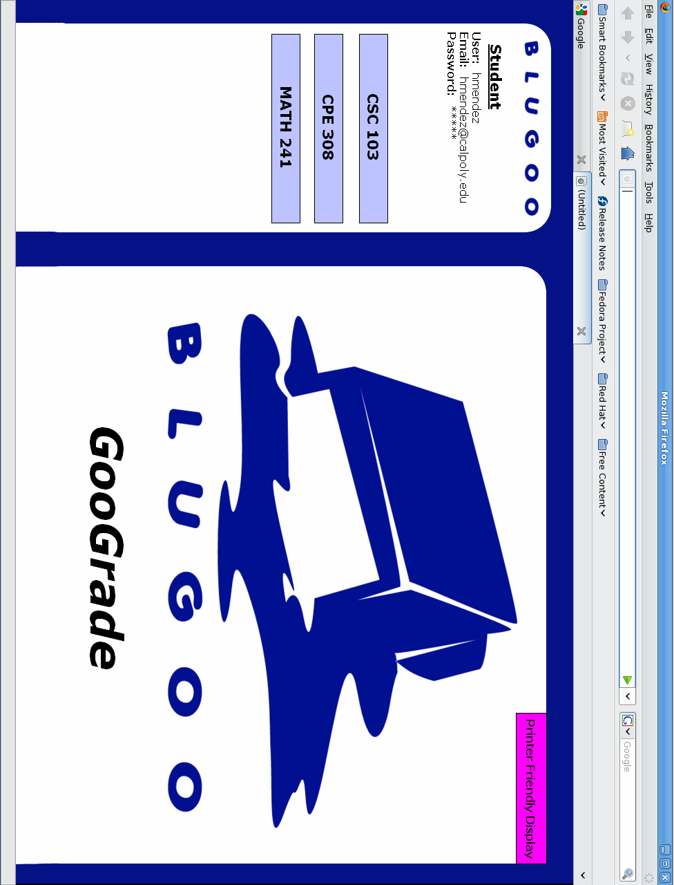
C-2: Student View Announcement

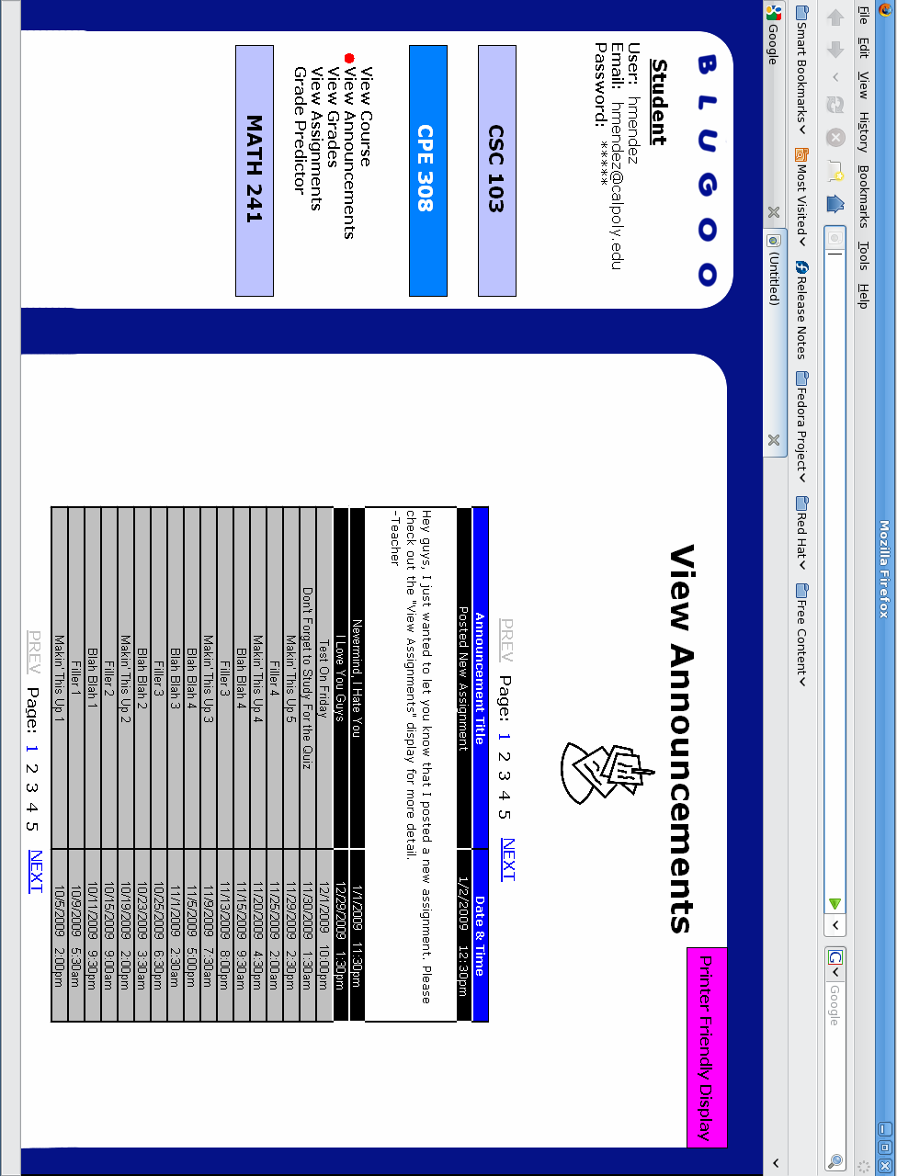
C-3: Student View Assignments

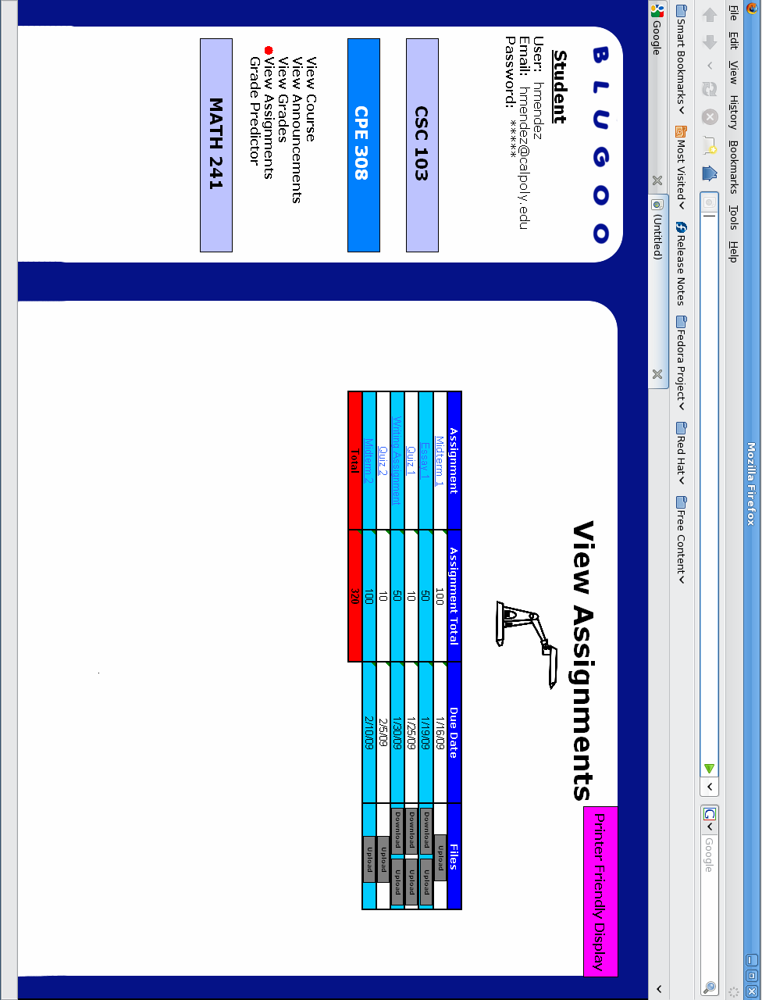
C-4: Student View Grades

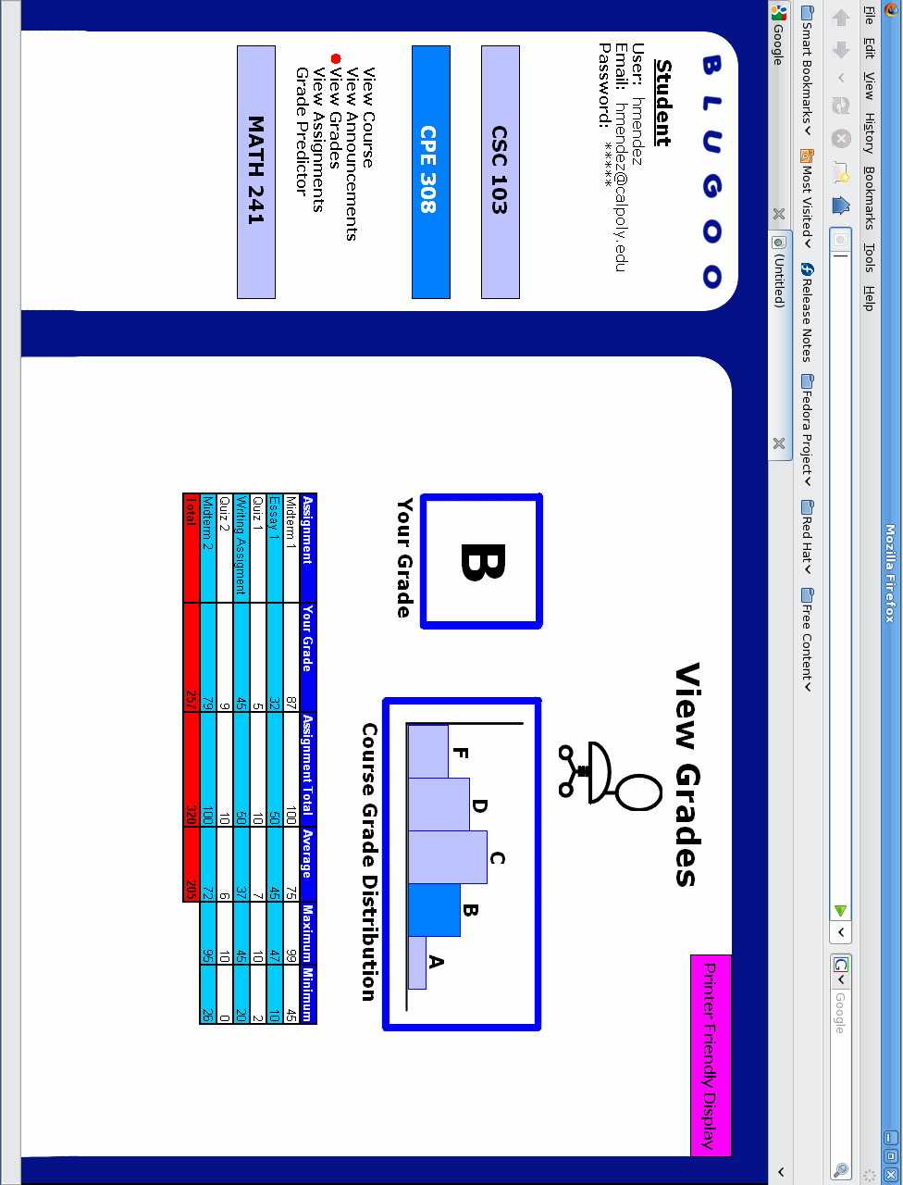
C-5: Student Grade Predictor

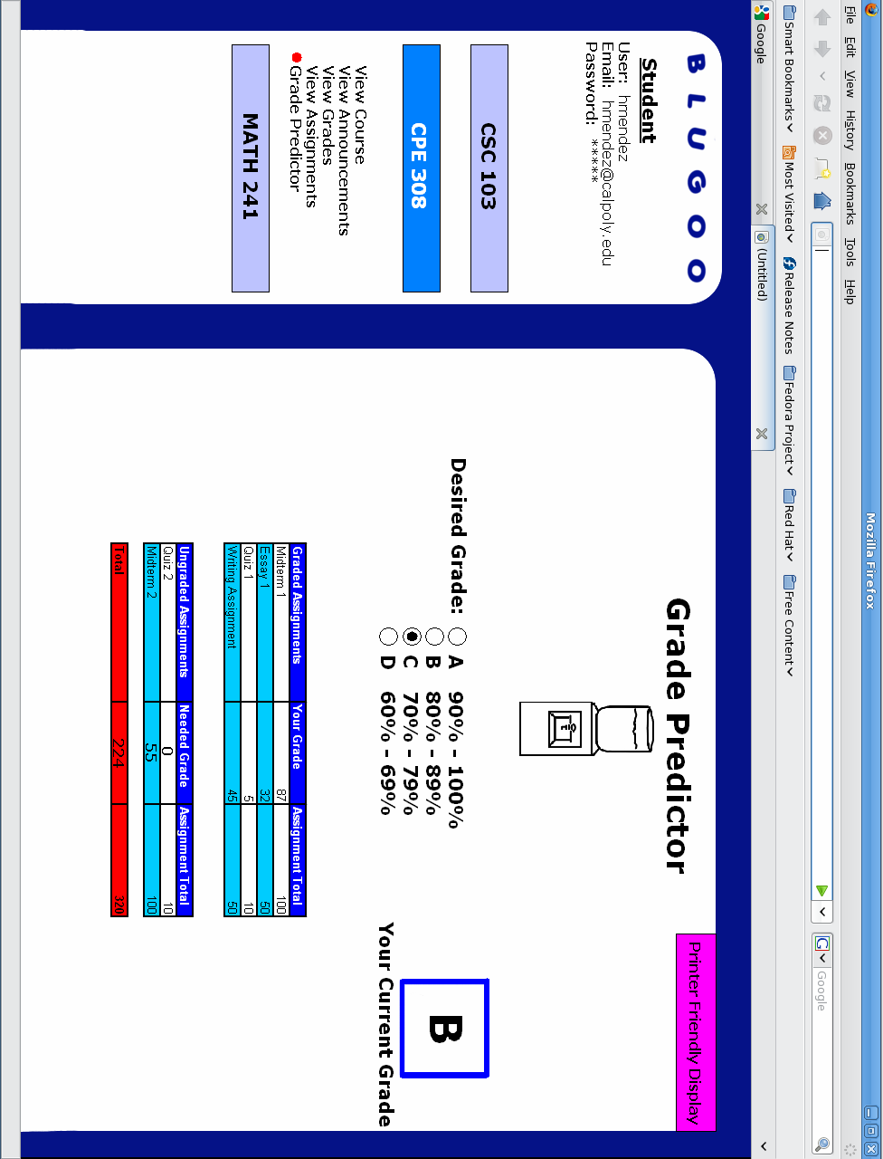
C-6: Student Edit Account

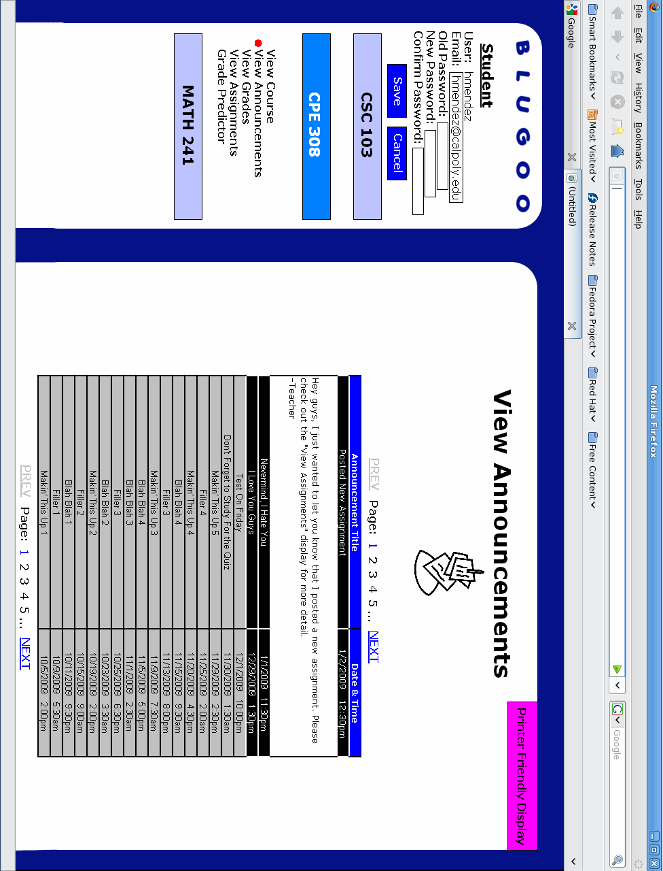
C-7: Student Edit Account Error

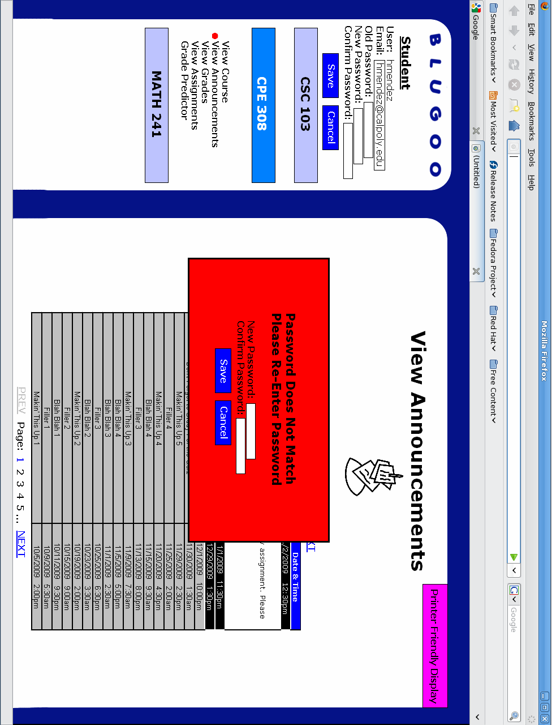
C-8: Teacher Homescreen

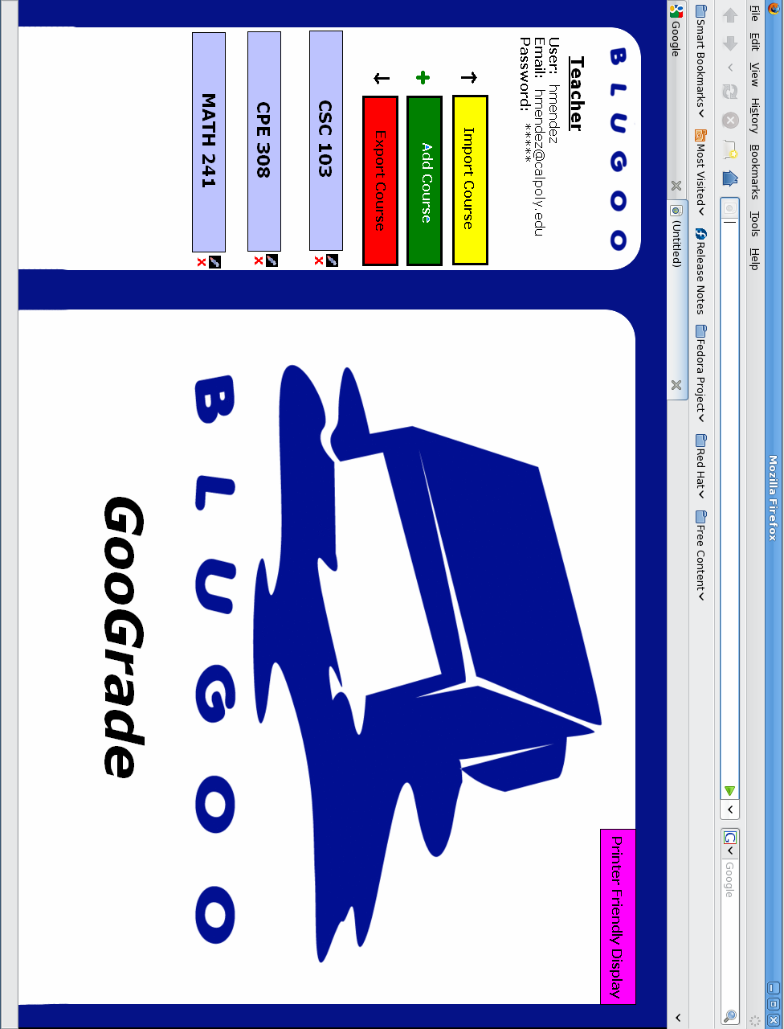
C-9: Teacher Manage Announcement

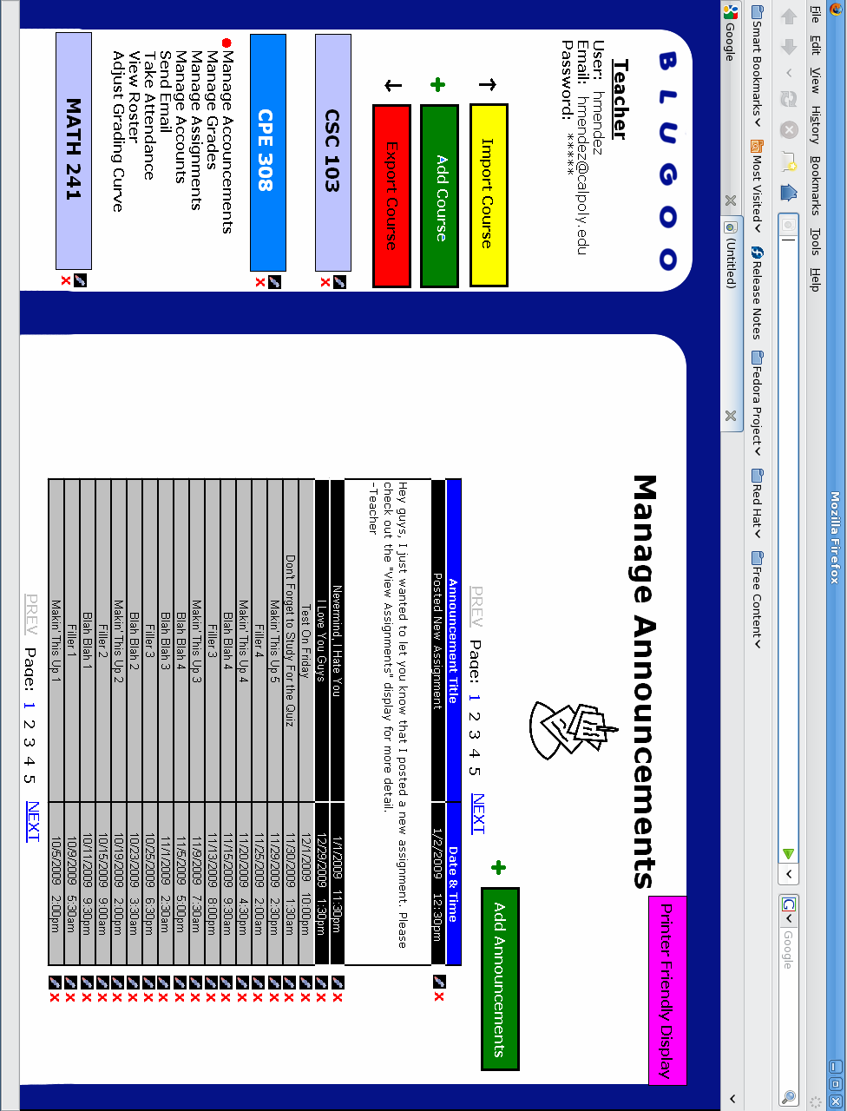
C-10: Teacher Manage Announcement Error

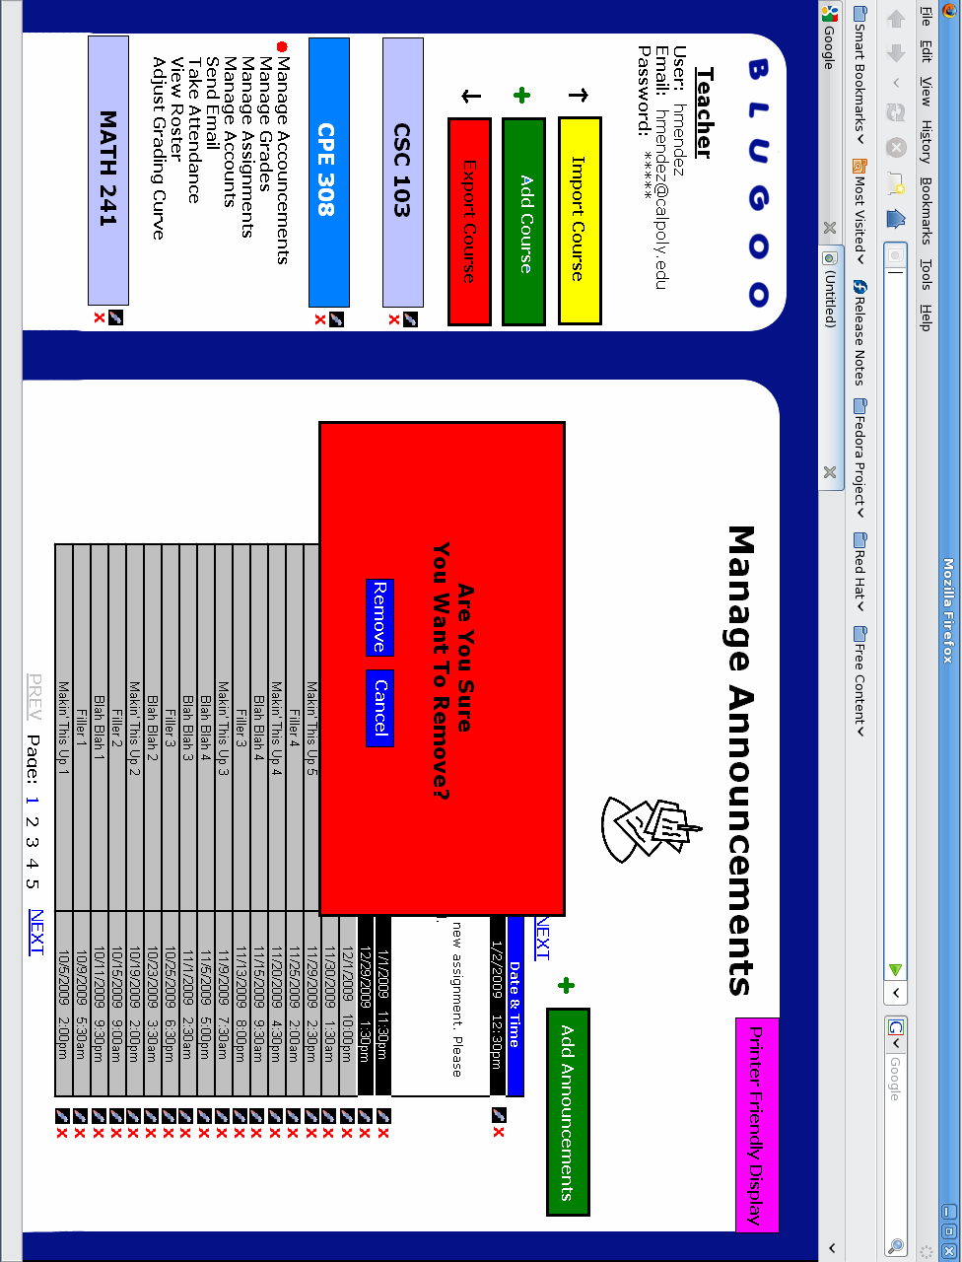
C-11: Teacher Manage Assignments

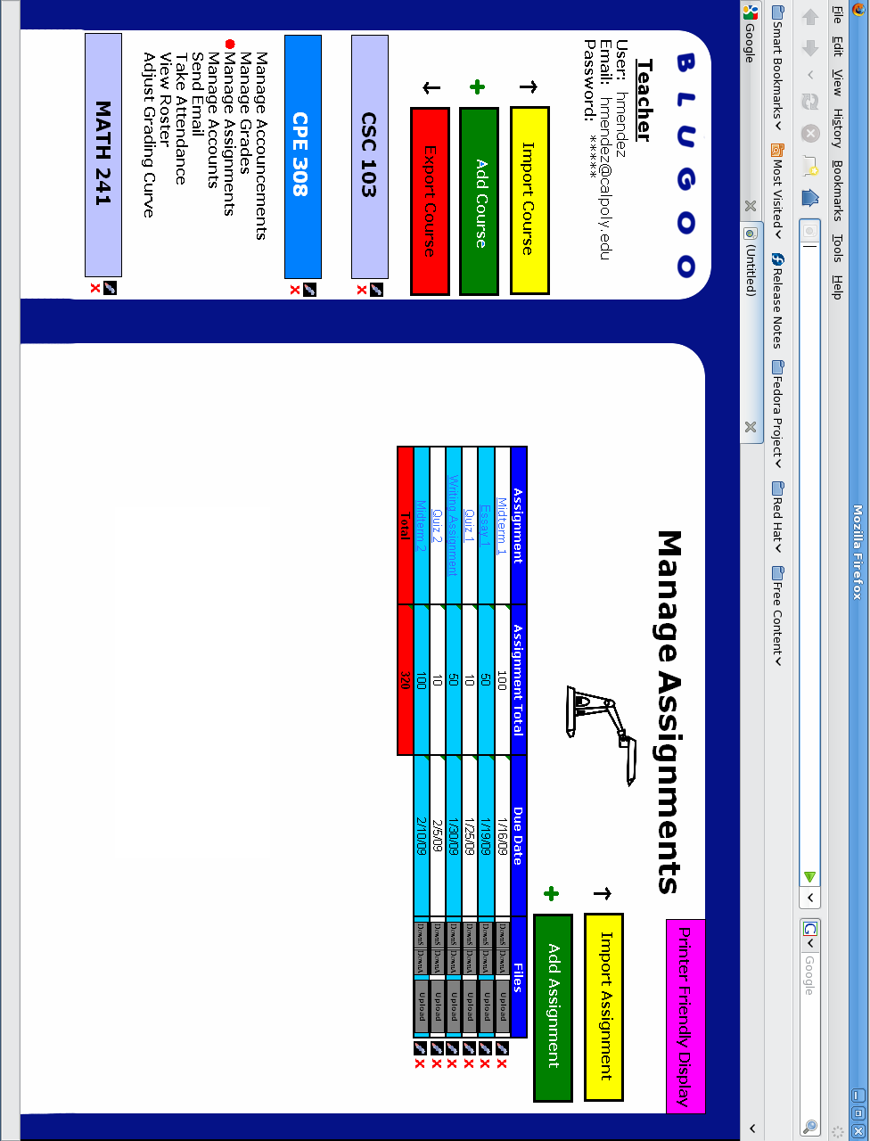
C-12: Teacher Manage Assignments Add

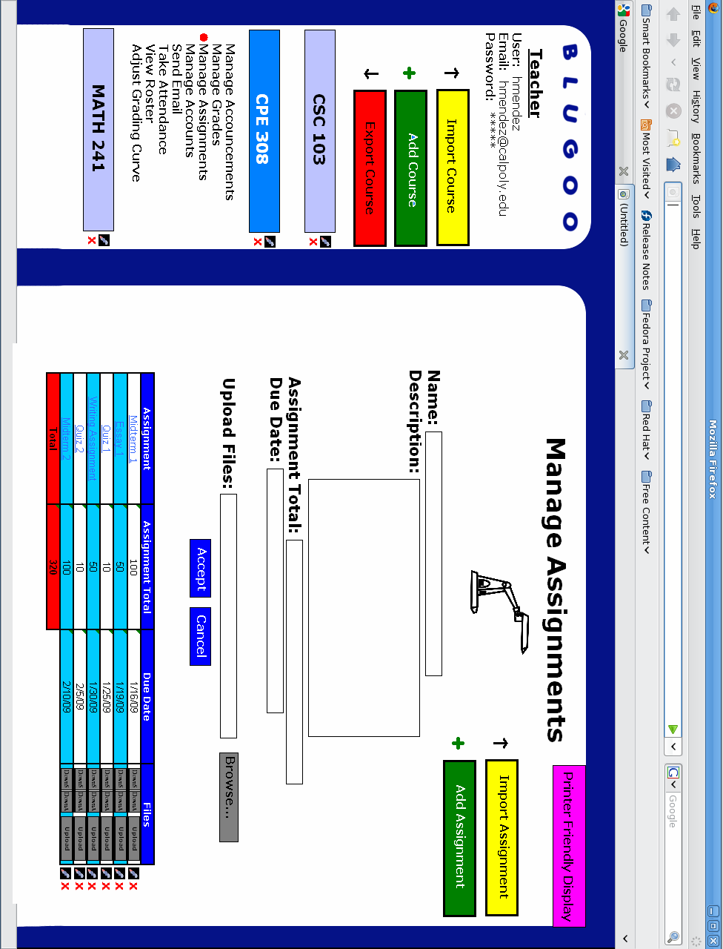
C-13: Teacher Manage Grades

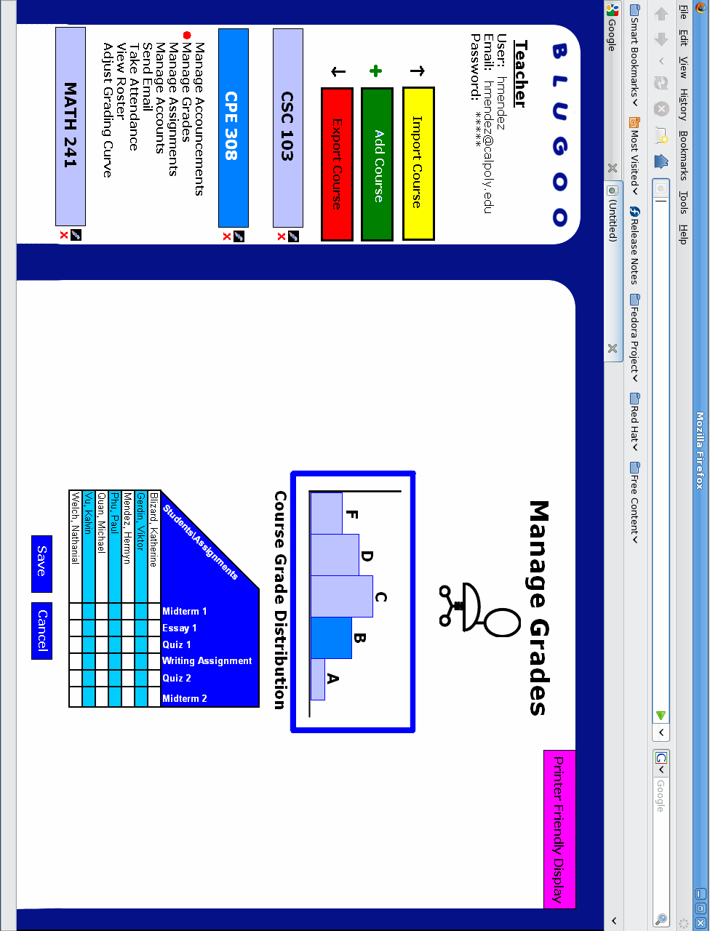
C-14: Teacher Manage Accounts

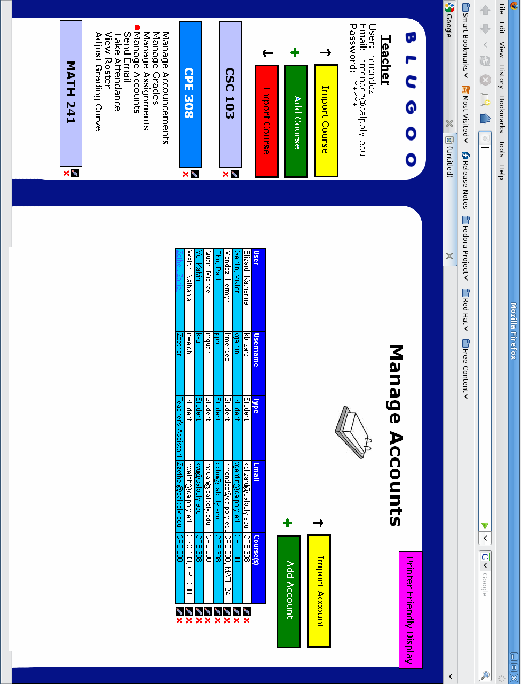
C-15: Teacher Manage Accounts Edit

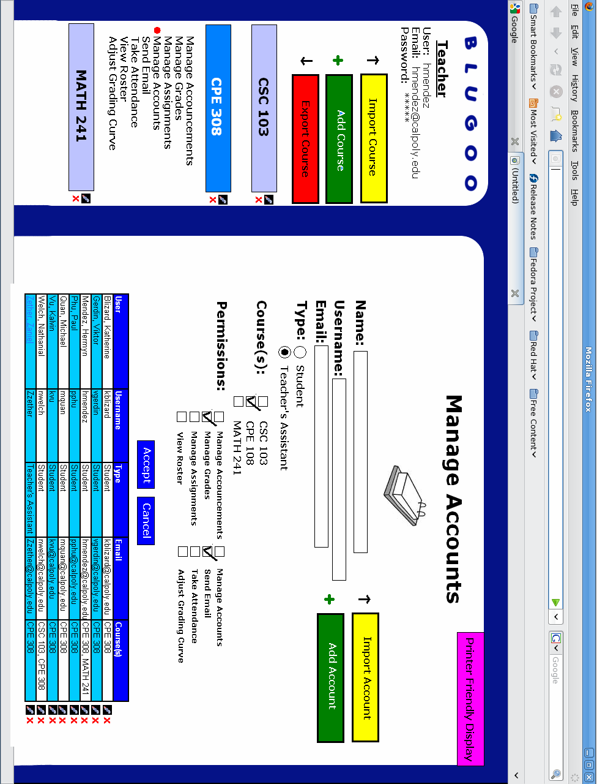

C-16: Take Attendance

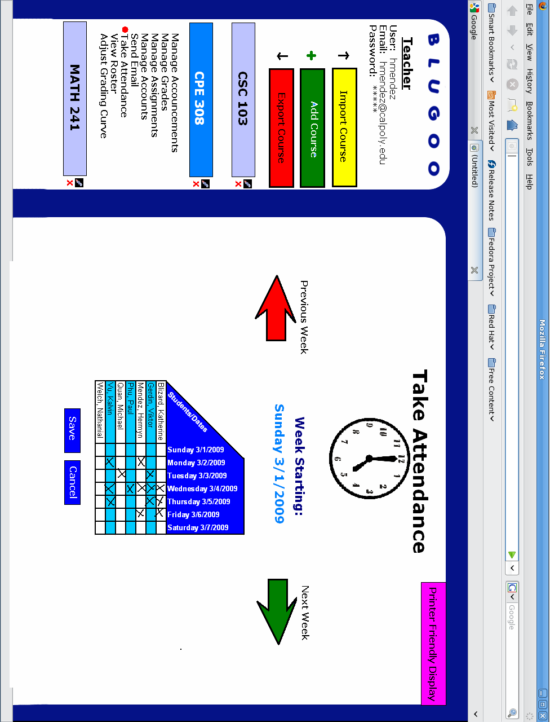
C-17: Teacher Adjust Grading Curve

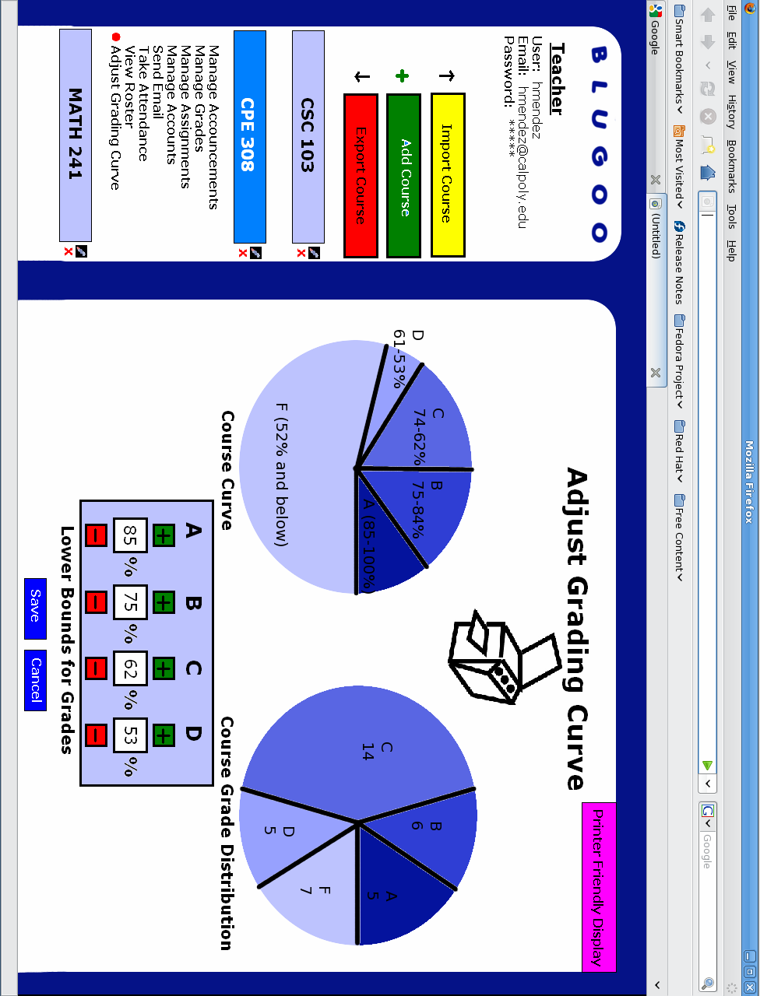
Appendix D: Issues List
Issue-1: File-size limitations on uploads
Issue-2: File format support
Issue-3: Use case document format
Issue-4: Review nonfunctional requirements

